Characterization of neuropeptide-receptor pairs in ancient Ctenophora



Leonardo Lenin Rosas Godinez

Supervised by Maria Sachkova

Research Project Report
A dissertation submitted to the University of Bristol in accordance with the requirements of the degree of Master of Science by advanced study in Bioinformatics in the Faculty of Health and Life Sciences

31/Aug/2026

Abstract: 183 words
Neuropeptide-GPCR pair repertoire is well characterized in bilaterians, but functionally unknown in ctenophores, an early-diverging non-bilaterian lineage. Characterizing their nervous system would assist in understanding the early nervous system evolution. An AlphaFold (AF)-multimer complex prediction across 16 neuropeptides against 234 Class-A GPCR candidates was carried out, followed by Molecular dynamics (MD) simulations in NAMD3 of the top-ranked complexes to test structural-dynamic stability. Peptide RMSD, COM distance, H-bond persistence and TM3-TM6 distance were the metrics used to evaluate the MD simulations. The AF models’ performance was in the range of iPTM=0.46-0.77, a moderate confidence range. Neurokinin-3 receptor, melatonin receptor 1A and the Cysteinyl leukotriene receptor 2 were the most abundant functional bilaterian-homolog annotations found for the GPCRs. Regarding MD, models remained overall stable based on steady H-bond perseverance, COM distance range and plateaued peptide RMSD, suggesting that AF-predicted complexes would be stable in biological conditions. TM3-TM6 distance measurements suggest that conformational change necessary for binding may already be present in the AF-predicted pose or may emerge later during MD. Together, AlphaFold and MD are complementary tools for prioritizing neuropeptide-receptor candidate pairs for future lab validation.

Keywords: Ctenophora, Neuropeptides, GPCRs, Molecular dynamics, AlphaFold, NAMD3

Wordcount: 3844 words
Dedication and Acknowledgements
Special thanks to my supervisor Maria Sachkova for the constant guidance, openness and support for this project. To Ibrahim Waiz, my friend, for his insightful discussions and company during this project. To the Biochem Club in UoB for their practical feedback and interest. And to my mother, father and sister, who made my postgraduate experience possible. Without them, I would not be here, fulfilling my dreams.

Declaration
I declare that the work in this dissertation was carried out in accordance with the requirements of the University’s Regulations and Code of Practice for Taught Programmes and that it has not been submitted for any other academic award. Except where indicated by specific reference in the text, this work is my own work. Work done in collaboration with, or with the assistance of others, is indicated as such. I have identified all material in this dissertation which is not my own work through appropriate referencing and acknowledgement. Where I have quoted or otherwise incorporated material, which is the work of others, I have included the source in the references. Any views expressed in the dissertation, other than referenced material, are those of the author.

31/Aug/2025

Table of Contents
- Aims and objectives
- Results
  - Computational workflow overview
  - AlphaFold complex predictions
  - Membrane composition derivation
  - MD proof-of-concept: Pep8 across 4 candidate systems
  - MD results: expanded peptide set
- Discussion
  - Interpreting AlphaFold results
  - Interpreting MD stability metrics
  - Limitations
  - Future work
- Conclusion
- References
- Figures and tables
- Supplementary Material

Aim(s) and Objectives: 257 words
The aim of this project is to identify candidate receptors for a given neuropeptide expressed in the nervous system of Mnemiopsis leidyi using AlphaFold (AF) as an AI-based structure prediction tool and Molecular dynamics to evaluate whether the AlphaFold models remained structurally stable and specifically associated in simulated time.
To achieve this, the project is structured in the following specific objectives
- Predict peptide-receptor complexes in AlphaFold 2
For this, 16 neuropeptide sequences from M. leidyi will be taken along with 234 M. leidyi filtered Class-A GPCRs to be input in AlphaFold. Each of the peptides will be run along the 234 receptors to rank the models with most favourable complexes via the iPTM score. To assess the function of the receptor candidate, BLAST and GPCRdb will be used to find approximated functions of the GPCR. Bilaterian functional annotation references will be employed given the lack of complete annotation in ctenophore biology.
- Assess the AlphaFold models with Molecular dynamics
For this, a Proof of concept with the highest AF-ranking model and 2 models for 3 additional peptide candidates will be run with CHARMM-GUI as input generator and NAMD3 as running software. The simulations will be evaluated based on COM (Centre of mass) distance between the biomolecules, H-bond persistence, peptide RMSD and TM3-TM6 (Transmembrane domains 3 and 6) distance between a GPCR-only control and a full neuropeptide-GPCR complex. All the systems will be embedded in a lipid membrane with the closest composition to the one in M. leidyi to approximate the biological conditions of the ctenophore environment.

Results [1646 words]
4.1 Computational workflow overview
16 peptide candidates were evaluated against GPCR targets identified through AlphaFold (AF) complex predictions [1]. Each neuropeptide had their own experiments, labelled as Pep0 for the first sequence, and PepX for the rest of them. Each experiment for each peptide was labelled as JobX to designate the order at which AF ran the simulations. The approach quality was assessed through the interface predicted template modelling score (iPTM). Residue binding locations were determined using Pymol [2] and closest-distance measurement tools available in the software. This was later used to determine extracellular domain (ECD), Transmembrane (TM) or intracellular domain (ICD) binding of the peptides to the receptor using DeepTMHMM [3] to query the receptors and obtain domain locations as reference. The top 3 GPCR candidates for each peptide were queried in BLAST [4] and GPCRdb [5] to assess the most likely function of the GPCR complex once a neuropeptide binds. Later, Molecular dynamics emerged as a tool to evaluate the trustworthiness of the AF models given its use to study dynamic interactions and its ability to simulate lipid membrane composition, ion concentration and water presence in time, as opposed to AF alone which gives only a static pose. To assess the simulations, 4 parameters were calculated: COM distance (The distance between the centre of mass of the GPCR and such from the neuropeptide), H-bond presence, peptide RMSD (a measurement of change in the location, rotation or angular position of the neuropeptide during the simulation) and TM3-TM6 distance (which measures the transmembrane domain aperture responsible for adjusting a peptide in a binding pocket).
4.2 AlphaFold complex predictions
Across all candidates, iPTM values ranged from 0.46 to 0.77 indicating a moderate confidence in the complex interfaces. The length of the peptide had no influence on the result. None of the results were above 0.8 in iPTM. Most of the predicted interactions exhibited mainly a mix of extracellular and slight transmembrane contact (Pep0, 1, 2, 3, 6, 7, 9, 10, 11, 12, 13 and 14), while others only extracellular contact (Pep 15), where they are supposed to bind to activate a downstream transduction signal pathway [6]. Peptide 4, 5 and 8 exhibit candidates with predicted intracellular binding. Pep8 is the one with the best performing models overall and the highest score among all the models. The next strongest candidates by top iPTM score would be Pep1 (0.73), Pep5 (0.71), Pep11 (0.70). As a result, the peptide binding location was used to design experiments for the next step in the project workflow (Molecular dynamics). Fig 1 shows the AlphaFold models for Pep0, 1, 2 and 8 for comparison.
The neurokinin-3 (NK3) (ID: ML177312a) receptor emerged as the most frequently predicted associated receptor among the peptide set. Showing up across 8 models (Pep0, 1, 7, 9, 10, 13, 14, 15). NK3 receptor association is followed by the melatonin receptor 1A (ML019812a) in 5 peptides and the Cysteinyl leukotriene receptor 2 (ML174738a) in 4 peptides as the next most common candidates. Table 1 summarizes the receptors with the most presence across the evaluated models with their corresponding biological context. A full list of GPCR candidates with their ID, iPTM scores and predicted annotation and peptides is available as supplementary material 1.
Having said this, the iPTM scores for some model candidates are low (<0.5). However, they are not enough to accept or discard the model as these low-performing models still predict extracellular binding (e.g. Pep0) in contrast to high-performing models with unlikely ICD binding (e.g. Pep8). It would need to be put to the test in biological conditions. This is where Molecular dynamics can aid the project using CHARMM-GUI [7] [8] as the input generator and NAMD3 [9] as the running software.

4.3 Membrane composition derivation
As the purpose of Molecular dynamics is to simulate a biological environment, deriving a lipid membrane is essential. Unfortunately, no literature has revealed a detailed lipid composition for M. leidyi. However, we can use the composition of another ctenophore: Bolinopsis vitrea. Winnikoff et al [10] determined such and the values were used as base for building the lipid membrane in CHARMM GUI. The final composition is shown in Table 2. Details of how it was built are found in Supplementary material 2.
4.4 MD proof-of-concept: Pep8 across 4 candidate systems
To test the approach, a first experiment with the Peptide8 model (The peptide with the best AF parameters during modelling) was carried out to assess the stability of a peptide bound to the top GPCR candidates as well as an apo-receptor control. A hypothesis would be that since Pep8 models are to this date unlikely given the ICD binding, a MD simulation should reflect the same via unstable parameters. During the initial 1 ns simulation, all complexes were successfully run. However, 1 ns is not enough to do an analysis. To determine an approximate simulation time which should be both insightful and not time-consuming given the time restraints, Younis et al [11] work served as reference. They determined the stability of their studied complexes at 10 ns, which led to an extension of this projects’ simulations to 10 ns as well to reveal distinct stability profiles among receptor candidates (Figure 2). Peptide 8 was tested across 3 peptide-bound systems: Complex membrane Job76 (B. vitrea inspired lipid membrane), simple-membrane Job76 (standard POPC lipid membrane), simple-membrane Job182 and one apo-control (No peptide, only GPCR system) for Job76. For the control, receptor RMSF showed a similar c-terminal flexibility spike seen in the peptide-bound systems, showing that GPCR flexibility is likely intrinsic to the receptor itself, rather than being provoked by peptide presence. Peptide RMSD increased abruptly across the 3 bound systems during the first half of the simulation, before plateauing in the second half. This reflects a general conformational state search that is not unique to any of the conditions. COM distance and H-bond presence oscillated in a stable range across the 3 systems, supporting a strong chemical attraction. Overall, these results influenced the following experiment designs. The Apo-control was considered worth keeping for the future tested models to study if in any scenario the presence of a peptide induces a conformational change in the GPCR. However, in the next experiments RMSF was replaced by the TM3 domain to TM6 (TM3-TM6) distance as it measures the aperture of specific domains to accommodate a peptide instead of measuring each residues’ flexibility. A comparison of the Complex membrane (CM) and Simple membrane (SM) system for Job76 shows superior COM distance stability (~2 A range in CM vs ~3 A range in SM) and H-bond presence (3-9 for CM and 2-8 for SM) behaviour. From this, the CM system was kept instead of a POPC-only system given its added stability. Finally, Job182 although ranked as number 2 in AlphaFold parameters had a more stable peptide RMSF value than Job76 (the one ranked as first). This indicated the need to test more than one AlphaFold model and not blindly rely on the supposition that the top 1 AlphaFold model is the best receptor pair for a specific neuropeptide.
4.5 MD results: expanded peptide set
After the first experiment with Peptide 8, new simulations were carried out using this setup: Temperature (18 C), 0.6 M NaCl and 10 ns time run. The simulations were evaluated using metrics such as COM distance, H bond abundance, Peptide RMSD and TM3-TM6 distance, whose transmembrane, extracellular and intracellular domains for each model were calculated using the DeepTMHMM tool [12].
Peptide 0: It was tested against model 9 and 63 (Figure 3). For both models, The TM3-TM6 aperture distance did not change with respect to their controls, meaning that the peptide presence barely influenced the conformation of the receptor. Job63 showed an unstable and unfinished RMSD trajectory, meaning the peptide had not found a stable pose yet during 10 ns, whereas in Job9 the peptide did. COM distance profiles behaved similarly for both, being stable which means the peptide did not dissociate from its original position. H-bond abundance was favourable for both profiles, being the H-bond number in a steady range, and in Job9, even approaching >10 bonds. In both cases, the chemical attachment is present. Due to RMSD trajectory and H-bonds, Job9 seems more favourable for Pep0.
Peptide1: It was tested against model 208 and 38 (Figure 4). Due to wall time limits (limits in HPC resource sharing) in the HPC, only 1 ns could be run. However, approximate insights can still be made. TM3-TM6 distance was measured for both using the Apo-protein system to be compared with the full system. For both models, the behaviour of the domains was similar although in different scales. It is probable that the peptide presence played a role in augmenting the distance between the domains as seen in the Figure 4. The peptide behaved similarly as per RMSD in both models, plateauing at roughly the same time. COM distance is different but of similar stable behaviour. H-bonds stands out nonetheless, where job 38 (being the 3rd best model in AF) exhibited more H-bonds than job208.
Peptide 2: It was tested against model 105 and 225 (Figure 5). TM3-TM6 distance was measured for both using the Apo-protein system to be compared with the full system. For job225, the distance profile is different, likely due to the presence of the peptide, where a more visible spike profile is present. The COM distance profile is of similar behaviour in both cases, where the fluctuation change is within the 2 A range. H bonds are present in both jobs, but job225 reflects a higher range of H bond abundance than job105. In both cases, the peptide RMSD reflects that the peptide was reaching a stable position, which is signalled by a plateaued curve and minor changes in distance of the peptide from its original position at the beginning of the simulation. Due to H-bonds and TM3-TM6 distance, job225 seems more favourable for Pep2.

Discussion [1693 words]
5.1 Interpreting the AF results
AlphaFold has been previously used to deorphanize GPCR peptide pairs. Danneskiold-Samsøe et al [13] have determined that the AI model possesses a high discriminatory power in predicting peptide-binding to a receptor, even for structures that are not available in PDB but rather in Uniprot. We wanted to verify the same robustness for an organism whose receptor structures are not available in any of these databases (more specifically located in the Mnemiopsis browser) [14] and whose peptides have been first-time sequenced, to assess if AlphaFold can predict high-quality complexes by looking at the iPTM value. For reference, the AlphaFold website states a iPTM>0.8 as a high confidence value threshold and iPTM<0.6 as not having reached a stable conformation [15]. After testing 16 peptides against 234 class-A GPCRs, AlphaFold top predictions are mostly in the grey zone (0.6-0.8) where predictions did not reach a structure consensus. This is because AlphaFold can find multiple complex arrangements but is still not able to favour a specific conformation over others, reducing the confidence in the result [15], with peptides 0, 3, 7, 9, 10, 12 and 15 containing low-confidence models. In other words, this leaves us in a grey zone where we could ambiguously trust most of the models produced by AlphaFold. And yet, using only AlphaFold would make the prediction of GPCR candidates for certain peptides with low-iPTM models unsuccessful, if characterization is the goal. As for the binding, given that the models exhibit a mix of extracellular and transmembrane binding, this suggests that the GPCR would have shape conformations that are adjusted to receive the Ctenophore peptides not only outside of the cell, but also at the transmembrane level. Intracellular binding predictions can be a result of AlphaFold not containing lipid-membrane context in their input, which opens the possibility of finding binding poses in biologically unlikely positions.
As for the functions, the fact that GPCRs related to NK3 receptor, Melatonin and leukotriene function (among others) present binding to more than one peptide suggests either a structural preference of the receptor for peptide ligands (making it a multipeptide receptor) or a common sequence feature shared among the candidate peptides. Furthermore, it has been observed that Ctenophores despite hitting homologs in BLAST and other databases, may not have the same machinery of neurogenic, immune and developmental genes. Compared to other animals, genes controlling patterning in nervous systems are absent in ctenophores (eg. neurogenines, REXT, HOX genes) [16]. A study by Moroz et al [16] hypothesized a convergent evolution of their nervous system. In this case, ctenophores may have lost neuronal and signalling tools and replaced them with their unique peptidergic (neuropeptide-based) nervous system. The table 1 containing probable functions for the peptide-receptor pairs should serve as a guide but not a definitive characterization of the GPCR repertoire, given that sequence homology assignment is not informative enough for function. Future characterization will determine one of two possibilities, either metazoans having evolved a less-elaborate nervous system which was reduced in placozoans and sponges, or that the neural cell types arose independently in ctenophores [16].
Moreover, the fact that multiple peptides bind to the same receptor matches with other deorphanization projects. For example, Thiel et al [17] deorphanized N. vectensis and found out that peptides ending in RPamide activate the same receptor R248 while some others activate a single receptor [17]. Of note, their pharmacological assays reveal that 1-3 peptides activate a receptor, although the receptor might have a preferred one. Table 1 and Supplementary material 1 again serve a starting point to find the first GPCR-peptide pairs, or possibly, GPCR-multipeptide pairs.
5.2 Interpreting MD stability metrics
Molecular dynamics revealed an approximate behaviour of the AF-predicted models in dynamic and biological conditions. Unfortunately, no GPCR-peptide studies in ctenophores using MD to evaluate RMSF, COM distance, H-bond presence or TM3-TM6 distance have been found, as to obtain a comparable positive control for ctenophores. Despite that, we can use the work of Younis et al [11], who analysed these values in mammals, to compare the ranges that would indicate stable and strong binding of the peptides to their receptors LPAR6. In their study, they confirmed their complex characterization by a RMSD range of (5-6 A), RMSF variability of ~2 Angstroms for their peptides, and 1-12 H-bonds range to trust a strong complex binding [11]. Based on these comparisons but considering that we are using a different GPCR group, the models for this project behave similarly in those ranges. For example, for RMSD (Pep0: 2-4 A, Pep1: 1-2 A, Pep2: 4-6 A) and H bond presence (Pep0: 5-12, Pep1: 1-6, Pep2: 3-8). Regarding COM distance, the best outcome is that the range was not volatile, which was the case for the models employed. These values support the bond strength between both biomolecules and deserve characterization in wet lab conditions to confirm the union. However, the models’ TM3-TM6 distance does not seem to follow a pattern. It has been accepted that the presence of a peptide can induce conformational changes in its receptor to activate a certain function, especially within the TM membrane to create a binding cavity [18]. In the case of GPCRs, an inactive state forms a saline bridge between the TM3 (DRY motif) and the TM6. Upon GPCR activation, TM6 moves upward, which is fundamentally a conformational change that permits binding [18]. In this project, the TM3-TM6 distance was measured comparing the Apo and the peptide-GPCR complex for each scenario. For Pep2, Job225 reflects that the distance between the 2 domains increased, which could point out to a conformational change to adjust the binding peptide, which confirms prior literature on the matter. The same could be suggested for Pep1 although more ns should be run to assess a more confident domain movement. This case is not apparent for Pep0 in any model. However, the reasons for this could be multifactorial. A strong supported reason would be that AlphaFold may have already predicted an active state for the GPCR before the MD simulations. It has been already observed that AF can predict either the active or inactive protein state of GPCRs depending on the training data already included in AlphaFold [19]. The implications are that AlphaFold can produce models which in the presence of a peptide, are still prone to more conformational changes, but it can still generate models that do not match the behaviour or are already shaped for peptide reception. The fact that conformational changes are suggested for some models plus the stable COM distance, peptide RMSD and H-bond presence values supports the possibility that the peptide-GPCR pair might be a match in biological conditions.
During this simulation, Pep8 was expected to perform somewhat poorly given the biological unlikelihood of the binding. At the same time, Pep0 models should have performed poorly because of its low confidence iPTM scores. Pep1 and 2 were in the grey zone and combined moderate iPTM scores with ECD binding. However, NAMD3 could not discriminate between biological likely and unlikely models when analysing the TM3-TM6 distance, H-bond presence, and RMSD. This is because NAMD3 just predicts the stability of a pose, not if the binding pose is biologically correct. At the same time, AlphaFold does not contain lipid layer awareness and is possible that will predict binding in both intracellular and extracellular locations. Since AF has little to no training in M. leidyi data, predictions should be examined one by one. Pep8 exhibited a stable behaviour, while being biologically implausible and surprisingly, Pep0 also exhibited a stable behaviour, while being of low confidence per AF scores. Pep1 and Pep2 exhibited stable parameters which give us confidence that AF can predict moderate confidence models and stable binding poses. Movies were generated for some models and are included as Supplementary Material 3
In short, AlphaFold structure modelling and Molecular dynamics are complementary, but should be integrated with manual analysis of the predictions since the binding could be predicted as either ICD or ECD, active and inactive. The workflow is presented as a tool to list potential targets for the sequenced neuropeptides and start characterizing the nervous system of ctenophores.
5.3 Limitations
There are limitations to the scope of the project. One of them is time restraints. More simulations for both the AlphaFold and the Molecular dynamics predictions could have been run, to obtain a larger list of GPCR-peptide candidates. However, the simulations as a whole take time being run on the HPC, so the number of experiments carried out was to still provide an analysis on the use of these tools. The same applies to the Molecular Dynamics simulations specifically. 10 ns can be in some cases insufficient to tell if a system has reached a stable position. At least for the systems tried, some appear to have a plateaued peptide RMSD. However, more time can be run depending on time flexibility to find the closest to a pose where biomolecules reach a stable range of motion. Time-wall limits play a crucial role because for some models the MD simulation did not fully finish running for 10 ns. The programming of the simulations was done in batches to attempt to distribute computational resources for the experiments in the shortest time possible. If more time and HPC space permits, models will be finished running and will be finished for downstream analysis. Despite that, insights could be made with the current data. Another limitation of the project is in the actual composition of a membrane in M. leidyi. Such membrane composition has not been fully characterized. Therefore, B. vitrea composition was employed. Still, this system is one of the closest to the actual membrane composition of M. leidyi, and the fact that is stable is encouraging and supports an accurate study of biomolecules interactions.
5.4 Future work
Future work involves the possibility of expanding the models tested for the remaining peptides to obtain GPCR candidates. along with a validated positive control during the simulations as the positive control comparisons available only exist in literature, and further experiments for these conditions could be time consuming. Finally, choosing a few GPCR candidates from the AF predictions for one peptide to test them in the lab is recommended to see if any of the predictions land with the correct peptide-receptor pair.

Conclusion: 221 words
The aim of this project was to characterize neuropeptide-receptor pairs for the M. leidyi ctenophore using AlphaFold as complex prediction tool and later characterize function and Molecular dynamics to assess complex stability in in-silico biological conditions. AlphaFold predicted GPCR candidates for 16 peptides with iPTM values between 0.46-0.77, making the models moderately trustworthy to be tested in lab conditions. The candidate list produced can be extended to an approximate characterization based on functional annotation of homolog bilaterian organisms but carefully considering that ctenophores may not have the same enzymatic machinery as other organisms, therefore expressing different functions. Molecular dynamics was evaluated for the models for peptides 8, 0, 1 and 2, resulting in TM3-TM6 distance changes visible for Pep2 and 1 but not the case for Pep0, suggesting that AlphaFold may predict active or inactive conformations of a GPCR based on its own training data, which could be revealed during Molecular dynamics. And yet, the model binding in any case is supported by stable ranges of COM distance, H bond presence, and in some cases plateaued peptide RMSD. An AlphaFold-structure analysis-Molecular dynamics workflow was generated as screening approach to predict GPCR candidates for peptides in uncharacterized nonbilaterian systems. The system can be expanded to obtain more candidates for under characterized neuropeptides and can be used as reference for wet-lab experiment designs.

Reference List
- Jumper J, Evans R, Pritzel A, Green T, Figurnov M, Ronneberger O, Tunyasuvunakool K, Bates R, Žídek A, Potapenko A, et al. Highly accurate protein structure prediction with AlphaFold. Nature. 2021;596(7873):583-589. doi:10.1038/s41586-021-03819-2.
- Schrödinger LLC. The PyMOL Molecular Graphics System [computer software]. Version X.X. Available from: https://pymol.org/
- Hallgren J, Tsirigos KD, Pedersen MD, Almagro Armenteros JJ, Marcatili P, Nielsen H, Krogh A, Winther O. DeepTMHMM predicts alpha and beta transmembrane proteins using deep neural networks. bioRxiv. 2022. doi:10.1101/2022.04.08.487609.
- Camacho C, Coulouris G, Avagyan V, Ma N, Papadopoulos J, Bealer K, Madden TL. BLAST+: architecture and applications. BMC Bioinformatics. 2009;10:421. doi:10.1186/1471-2105-10-421.
- Pándy-Szekeres G, Munk C, Tsonkov TM, Mordalski S, Harpsøe K, Hauser AS, Bojarski AJ, Gloriam DE. GPCRdb in 2018: adding GPCR structure models and ligands. Nucleic Acids Res. 2018;46(D1):D440-D446. doi:10.1093/nar/gkx1109.
- Duan Sahbaz B, Ilyison NB. Neuropeptides as ligands for GPCRs. In: Saravanan C, Biswas B, editors. Ligand. London: IntechOpen; 2018. doi:10.5772/intechopen.73504.
- Jo S, Kim T, Iyer VG, Im W. CHARMM-GUI: a web-based graphical user interface for CHARMM. J Comput Chem. 2008;29(11):1859-1865. doi:10.1002/jcc.20945.
- Brooks BR, Brooks CL 3rd, MacKerell AD Jr, Nilsson L, Petrella RJ, Roux B, Won Y, Archontis G, Bartels C, Boresch S, et al. CHARMM: the biomolecular simulation program. J Comput Chem. 2009;30(10):1545-1614. doi:10.1002/jcc.21287.
- Phillips JC, Hardy DJ, Maia JDC, Stone JE, Ribeiro JV, Bernardi RC, Buch R, Fiorin G, Hénin J, Jiang W, et al. Scalable molecular dynamics on CPU and GPU architectures with NAMD. J Chem Phys. 2020;153(4):044130. doi:10.1063/5.0014475.
- Winnikoff JR, Milshteyn D, Vargas-Urbano SJ, Pedraza-Joya MA, Armando AM, Quehenberger O, Sodt A, Gillilan RE, Dennis EA, Lyman E, et al. Homeocurvature adaptation of phospholipids to pressure in deep-sea invertebrates. Science. 2024;384(6703):1482-1488. doi:10.1126/science.adm7607.
- Younis S, Rashid S. Alpha conotoxin-BuIA globular isomer is a competitive antagonist for oleoyl-L-alpha-lysophosphatidic acid binding to LPAR6; a molecular dynamics study. PLoS One. 2017;12(12):e0189154. doi:10.1371/journal.pone.0189154.
- Hallgren J, Tsirigos KD, Pedersen MD, Almagro Armenteros JJ, Marcatili P, Nielsen H, Krogh A, Winther O. DeepTMHMM predicts alpha and beta transmembrane proteins using deep neural networks. bioRxiv. 2022. doi:10.1101/2022.04.08.487609.
- Banhos Danneskiold-Samsøe N, Kavi D, Jude KM, Nissen SB, Wat LW, Coassolo L, Zhao M, Santana-Oikawa GA, Broido BB, Garcia KC, et al. AlphaFold2 enables accurate deorphanization of ligands to single-pass receptors. Cell Syst. 2024;15(11):1046-1060.e3. doi:10.1016/j.cels.2024.10.004.

- Ryan JF, Pang K, Schnitzler CE, Nguyen AD, Moreland RT, Simmons DK, Koch BJ, Francis WR, Havlak P, NISC Comparative Sequencing Program, et al. The genome of the ctenophore Mnemiopsis leidyi and its implications for cell type evolution. Science. 2013;342(6164):1242592. doi:10.1126/science.1242592.
- EMBL-EBI. Confidence scores in AlphaFold-Multimer [Internet]. European Bioinformatics Institute. Available from: https://www.ebi.ac.uk/training/online/courses/AlphaFold/inputs-and-outputs/evaluating-AlphaFolds-predicted-structures-using-confidence-scores/confidence-scores-in-AlphaFold-multimer/
- Moroz LL, Kocot KM, Citarella MR, Sohn D, Norekian TP, Povolotskaya IS, Grigorenko AP, Dailey C, Berezikov E, Buckley KM, et al. The ctenophore genome and the evolutionary origins of neural systems. Nature. 2014;510(7503):109-114. doi:10.1038/nature13400.
- Thiel D, Yañez Guerra LA, Kieswetter A, Cole AG, Temmerman L, Technau U, Jékely G. Large-scale deorphanization of Nematostella vectensis neuropeptide G protein-coupled receptors supports the independent expansion of bilaterian and cnidarian peptidergic systems. eLife. 2024;12:RP90674. doi:10.7554/eLife.90674.
- Kim J, Kim J, Choi C, Bae J, Choi HJ. Structural insights into GPCR signaling activated by peptide ligands: from molecular mechanism to therapeutic application. Exp Mol Med. 2025;57(7):1467-1481. doi:10.1038/s12276-025-01497-y.
- Heo L, Feig M. Multi-state modeling of G-protein coupled receptors at experimental accuracy. Proteins. 2022;90(11):1873-1885. doi:10.1002/prot.26382.
- Ahmed NA, Hussein AA, Khalil RG, Yassin NYS, Abdelaziz MA, Geddawy AI, Ahmed OM. Chemerin normal function and roles in metabolic and nonmetabolic disorders: an up-to-date comprehensive review. Biochem Res Int. 2026;2026:1761697. doi:10.1155/bri/1761697.
- Perez DM. α1-Adrenergic receptors in neurotransmission, synaptic plasticity, and cognition. Front Pharmacol. 2020;11:581098. doi:10.3389/fphar.2020.581098.
- Bruell S, Sethi A, Smith N, Scott DJ, Hossain MA, Wu QP, Guo ZY, Petrie EJ, Gooley PR, Bathgate RAD. Distinct activation modes of the Relaxin Family Peptide Receptor 2 in response to insulin-like peptide 3 and relaxin. Sci Rep. 2017;7:3294. doi:10.1038/s41598-017-03638-4.
- Liang Z, Wu G, Fan C, Xu J, Jiang S, Yan X, Di S, Ma Z, Hu W, Yang Y. The emerging role of signal transducer and activator of transcription 3 in cerebral ischemic and hemorrhagic stroke. Prog Neurobiol. 2016;137:1-16. doi:10.1016/j.pneurobio.2015.11.001.
- Kalinina DS, Ptukha MA, Goriainova AV, Merkulyeva NS, Kozlova AA, Murtazina RZ, Shemiakova TS, Kuvarzin SR, Vaganova AN, Volnova AB, et al. Role of the trace amine associated receptor 5 (TAAR5) in the sensorimotor functions. Sci Rep. 2021;11:23092. doi:10.1038/s41598-021-02289-w.
- Dearwester K. NK1 tachykinin receptor. In: Enna SJ, Bylund DB, editors. xPharm: The Comprehensive Pharmacology Reference. Elsevier; 2009. p. 1-14. doi:10.1016/B978-008055232-3.63782-1.
- Low MJ. Neuroendocrinology. In: Melmed S, Polonsky KS, Larsen PR, Kronenberg HM, editors. Williams Textbook of Endocrinology. 12th ed. Elsevier Saunders; 2011. p. 103-174. doi:10.1016/B978-1-4377-0324-5.00007-9.
- Bianchi ME, Mezzapelle R. The chemokine receptor CXCR4 in cell proliferation and tissue regeneration. Front Immunol. 2020;11:2109. doi:10.3389/fimmu.2020.02109.
- BenchChem Technical Support Team. The physiological role of the cysteinyl leukotriene 2 receptor (CysLT2R): an in-depth technical guide. BenchChem; 2026 Apr. Available from: https://pdf.benchchem.com/8692/The_Physiological_Role_of_the_Cysteinyl_Leukotriene_2_Receptor_CysLT2R_An_In_depth_Technical_Guide.pdf
- Bockaert J, Claeysen S, Compan V, Dumuis A. 5-HT4 receptors, a place in the sun: act two. Curr Opin Pharmacol. 2011;11(1):87-93. doi:10.1016/j.coph.2011.01.012.
- Ögren SO, Kuteeva E, Elvander-Tottie E, Hökfelt T. Neuropeptides in learning and memory processes with focus on galanin. Eur J Pharmacol. 2010;626(1):9-17. doi:10.1016/j.ejphar.2009.09.070.
- Acher R. Neurohypophysial hormone regulatory systems. In: Luciano M, editor. Encyclopedia of Endocrine Diseases. Amsterdam: Elsevier; 2004. p. 314-329. ISBN 9780124755703.
- Jones-Tabah J, Mohammad H, Paulus EG, Clarke PBS, Hébert TE. The signaling and pharmacology of the dopamine D1 receptor. Front Cell Neurosci. 2022;15:806618. doi:10.3389/fncel.2021.806618.
- Karolczak EO, Li C, Alcantara IC, Cohen IM, Gao C, Xiao C, Goldschmidt AI, Pinkus CA, Li J, Li MM, et al. Uncovering the role of Gpr45 in obesity regulation. Mol Metab. 2025;98:102174. doi:10.1016/j.molmet.2025.102174.
- Nishino S, Mignot E. Wake-promoting medications: basic mechanisms and pharmacology. In: Kryger MH, Roth T, Dement WC, editors. Principles and Practice of Sleep Medicine. 5th ed. St. Louis: Elsevier Saunders; 2011. p. 510-526.
- Leadley RJ Jr, Chi L, Porcari AR. Non-hemostatic activity of coagulation factor Xa: potential implications for various diseases. Curr Opin Pharmacol. 2001;1(2):169-175. doi:10.1016/S1471-4892(01)00033-9.
- Zhang CL, Han QW, Chen NH, Yuan YH. Research on developing drugs for Parkinson's disease. Brain Res Bull. 2021;168:100-109. doi:10.1016/j.brainresbull.2020.12.017.
- Farhan A, Gulati J, Große-Wilde E, Vogel H, Hansson BS, Knaden M. The CCHamide 1 receptor modulates sensory perception and olfactory behavior in starved Drosophila. Sci Rep. 2013;3:2765. doi:10.1038/srep02765.
- O'Shaughnessy KM. Respiratory system. In: Ritter JM, Flower RJ, Henderson G, Loke YK, MacEwan DJ, Rang HP, editors. Clinical Pharmacology. 11th ed. Edinburgh: Elsevier; 2012. p. 467-479. doi:10.1016/B978-0-7020-4084-9.00067-7.

- Hoyer D. SST-1 somatostatin receptor. In: xPharm: The Comprehensive Pharmacology Reference. Elsevier; 2007. p. 1-12. doi:10.1016/B978-008055232-3.60344-7.

Figures and Tables

Biological function (source) | Context | Models with their presence
Chemerin receptor  (ML00732a) | Immune cell trafficking, adipogenesis, glucose and lipid homeostasis [20] | Pep0
NK3 receptor  (ML074223a) | Neurotransmission and regulating sympathetic nervous system by norepinephrine and epinephrine [21] | Pep0, Pep1, Pep7, Pep9, Pep10, Pep13, Pep14, Pep15
Relaxin receptor 2-like  (ML141721a) | Reproductive function. Activated by insulin-like peptide 3 and gene2 relaxin in humans [22] | Pep1
Angiotensin II type 1 receptor  (ML029513a) | More plentiful in fetus and neonates. Inhibition of cell growth, neuronal regeneration and cellular differentiation [23] | Pep1, Pep11
TAAR5-like receptor  (ML07755a) | Suggested to behave in the vestibular and motor control, muscle force and balance [24] | Pep2, Pep6
Tachykinin receptor  (ML398316a) | Activation of NK1 receptors through Substance P ligand. Regulates efflux to cardiovascular structures. May be involved in body’s stress response [25] | Pep2, Pep5, Pep11
Melatonin receptor 1A  (ML019812a) | Melatonin is involved in inhibiting activity of neurons in the SCN of the hypothalamus, involved in circadian rhythm in humans [26]. | Pep2, Pep3, Pep4, Pep7, Pep13
Chemokine receptor 4  (ML311633a) | Triggers cell migration, hematopoiesis, retention and bone marrow, cell proliferation and tissue regeneration [27] | Pep3
Cysteinyl leukotriene receptor 2 (ML174738a) | Plays role in inflammatory and allergic responses [28] | Pep3, Pep4, Pep6, Pep15, Pep8, Pep10
5-HT4 receptor  (ML21651a) | Involved in learning and memory, feeding and mood behaviour and gastro intestinal transit [29] | Pep4, Pep11, Pep12
Galanin receptor 2  (ML11688a) | Mediates stimulatory effects of galanin on neutransmisser release [30] | Pep5, Pep13, Pep14, Pep15
Vasopressin V1a receptor  (ML102913a) | Expressed in the periphery of smooth muscles of blood vessels conveying blood pressure [31] | Pep5
Dopamine D1A receptor  (ML00013a) | Expressed in midbrain and forebrain regulating motor behaviour and reward states and cognitive processes [32] | Pep6
Galanin receptor 1  (ML101016a) | Involved in a system distributed in the brain and mediates inhibitory actions of galanin [30]. | Pep7
GPR45  (ML17472a) | Involved in signalling and neural activity in regulating bodyweight and appetite [33] | Pep8
TRH receptor  (ML000129a) | Enhances dopamine and norepinephrine neurotransmission, as well as possible wake-promoting and anticataleptic effects [34] | Pep9
Proteinase-activated receptor 2  (ML046710a) | Involved in mitogenesis [35] | Pep9
Adenosine A2 receptor  (ML074214a) | Low affinity to adenosine. Decreases neural firing rate and inhibits neurotransmitter release [36] | Pep10
CCHamide-1 receptor  (ML016344a) | Involved in olfactory responses in Drosophila [37] | Pep12
Histamine H2 receptor  (ML46823a) | Involved in release of gastric acid [38] | Pep12
Somatostatin receptor 1-like  (ML15725a) | Neuronal excitability and reduction of neuronal firing and anticonvulsant and antiepileptic [39] | Pep14
Table 1. Homolog-predicted functional annotations for the GPCR candidates during AlphaFold predictions. Functions may differ in M. leidyi due to possible lack of the same enzymatic machinery in other organisms.
Category in CHARMM-GUI | Lipid | Upper | Lower
Ether/Plasmalogen Lipids | POPEE | 25 | 25
PE Lipids | DOPE | 15 | 15
Ether/Plasmalogen Lipids | POPCEE | 10 | 10
PC Lipids | POPC | 20 | 20
PS Lipids | POPS | 12 | 12
PI Lipids | POPI | 3 | 3
Sterols | Cholesterol | 10 | 10
PE Lipids | PLPE | 5 | 5
Table 2. B. vitrea inspired lipid membrane composition for Molecular dynamics simulations of M. leidyi GPCR-peptide candidates. The values presented serve as input for CHARMM GUI generator.
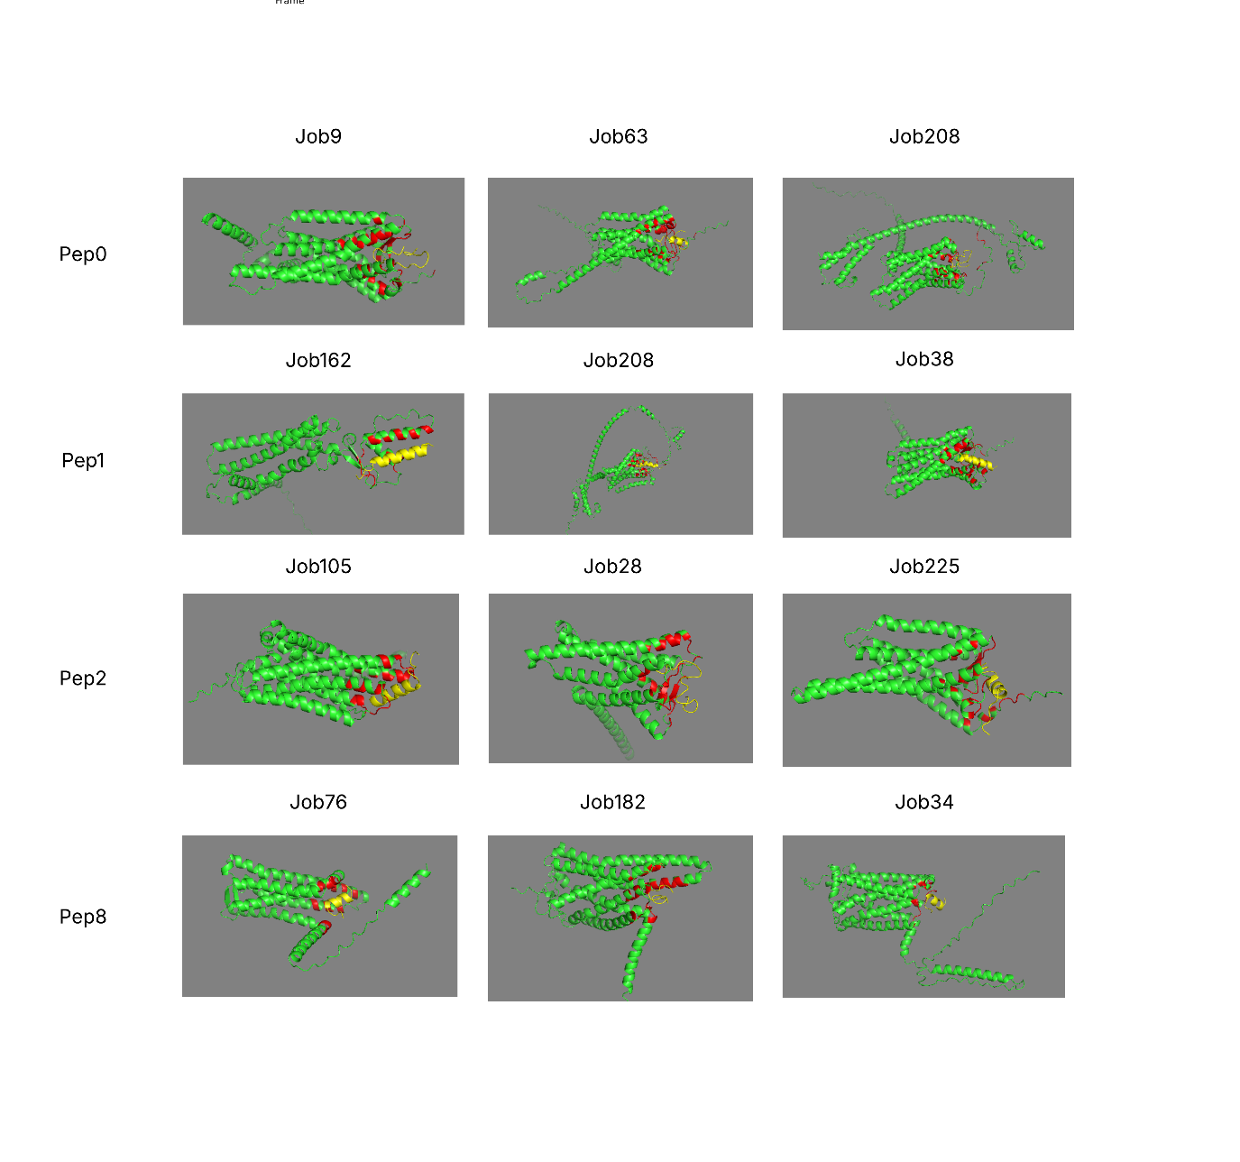
Fig 1. AlphaFold complex predictions for Pep0, 1, 2 and 8. The top 3 best performing models are shown. Green: GPCR. Yellow: Neuropeptide. Red: Closest GPCR residues to neuropeptide.

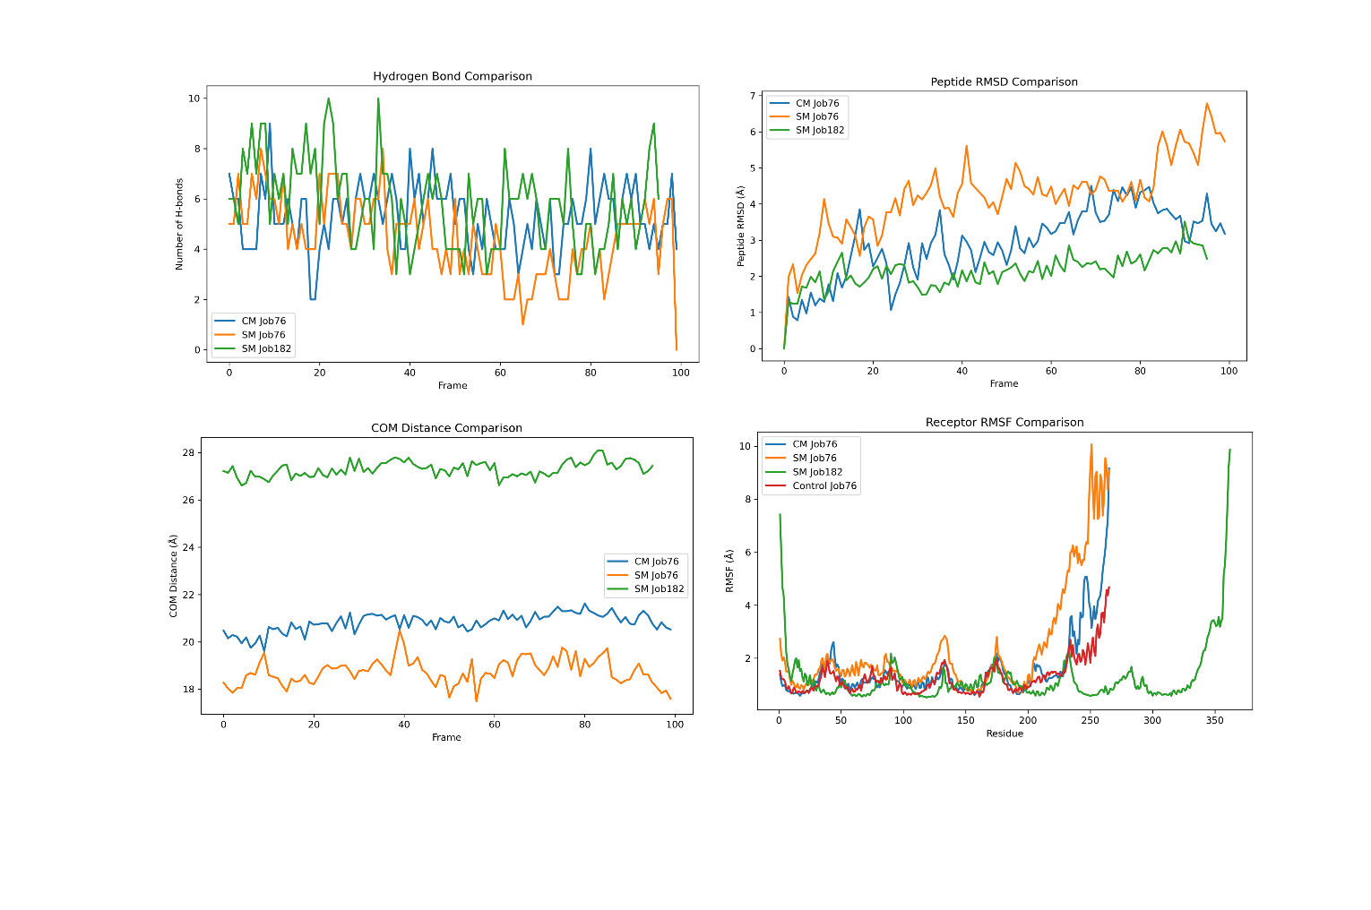
Figure 2. Proof of concept experiments with Peptide 8. Apo-protein refers to a non-functional control which includes a POPC membrane with the candidate GPCR from the AlphaFold Job 76. CM for Pep8Job76 refers to a system with a B. vitrea inspired complex lipid composition (with up to 8 components. See Table 2). SM for both Pep8Job76 and Pep8Job102 refer to the respective AlphaFold-predicted complexes containing a standard POPC membrane for comparison to the Complex membrane (CM).

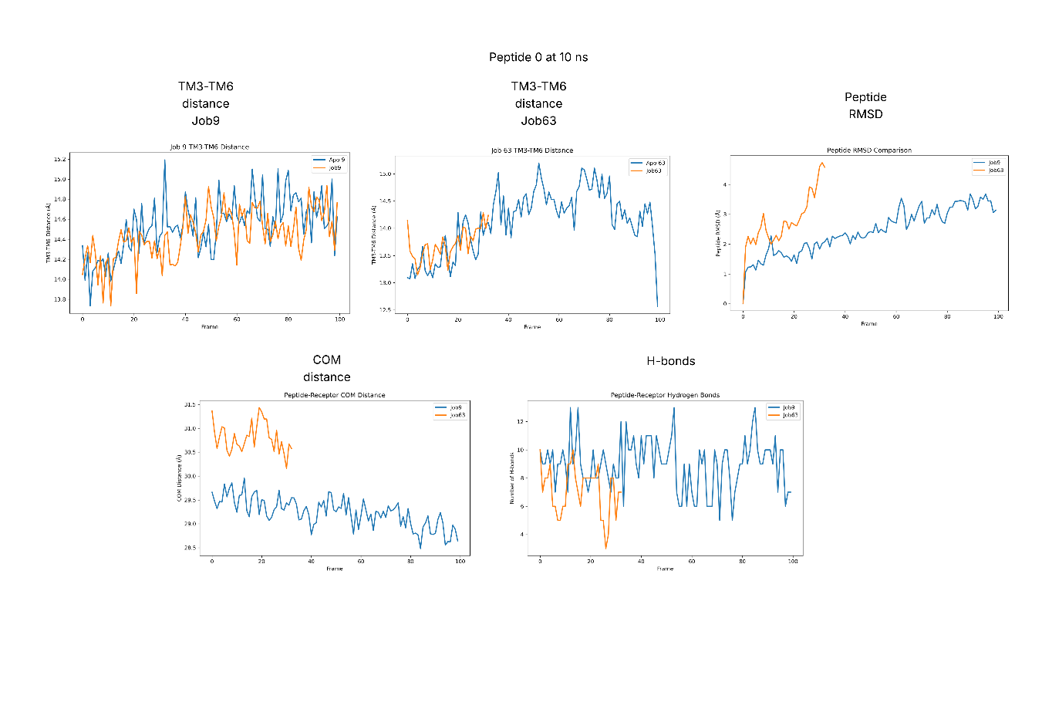
Figure 3. Peptide 0 Molecular dynamics analysis. TM3-TM6 distance was measured between Control and full system for Job9 and Job63. Peptide RMSD, COM distance and H-bonds were also compared for both models. Job63 was stopped in HPC due to wall-time limits but still provided enough trajectory for analysis.
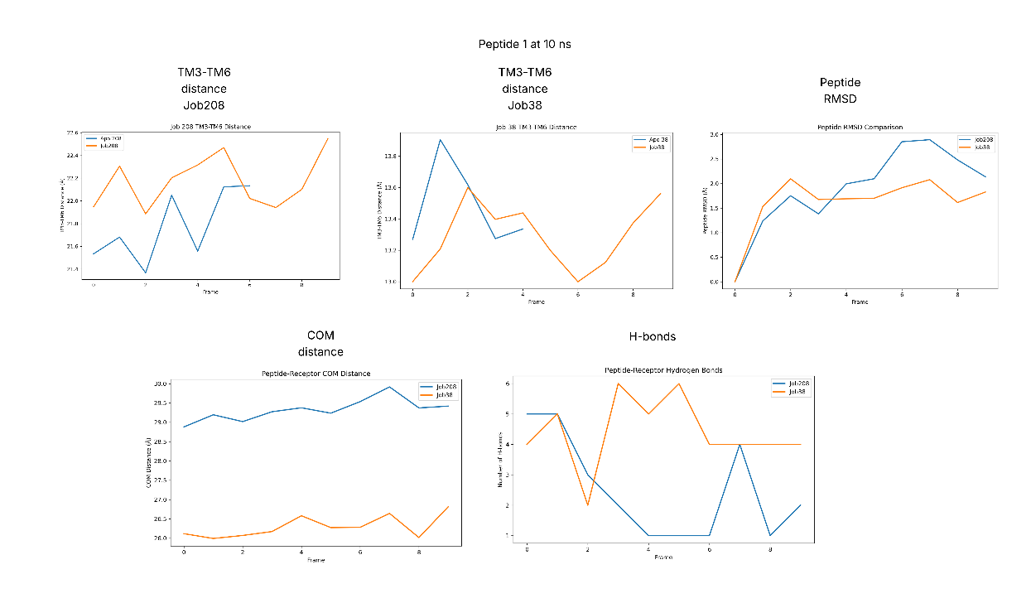
Figure 4. Peptide 1 Molecular dynamics analysis. TM3-TM6 distance was measured between Control and full system for Job208 and Job38. Peptide RMSD, COM distance and H-bonds were also compared for both models. Wall-time limits did not permit timely generation of an extended 10ns analysis. Therefore, 1 ns is presented for discussion.

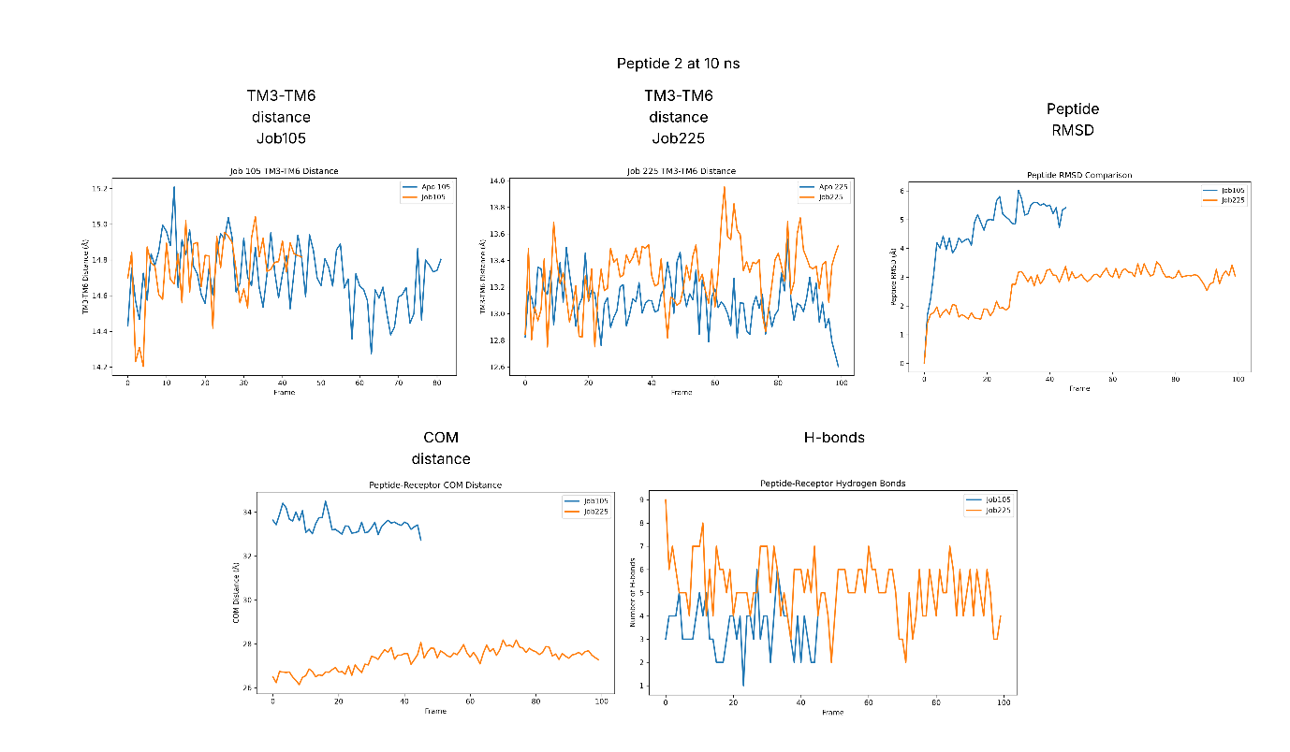
Fig. 5. Peptide 2 Molecular dynamics analysis. TM3-TM6 distance was measured between Control and full system for Job105 and Job225. Peptide RMSD, COM distance and H-bonds were also compared for both models. Job63 was stopped in HPC due to wall-time limits but still provided enough trajectory for analysis.

Supplementary Material
Supplementary material 1: List of neuropeptide pairs with top 3 GPCR candidates, iPTM, binding and possible homolog-function characterization.
Supplementary material 2: Description of Lipid membrane creation.
Supplementary Material 3: Movies of MD simulations

